HOP 2 processes one provider at a time. Each provider from HOP 1 produces a separate CapProvProc message, and cBuildCapEnrolls runs independently for a single @affiliateid. The enrollment SELECT is restricted to that one provider:
cBuildCapEnroll:

- Resolve the batch size
This step checks for
reqCAPSize > 0 - Max enrollees per batch (legacy default 500).
reqCAPSize = 0 - "No Limit" — the provider becomes a single batch.

- Summary + global short-circuit
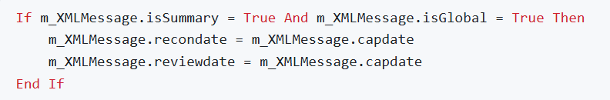
A "summary" global run is a projection of the current month only — it must not reach back and re-reconcile prior months. Collapsing recondate onto capdate narrows every later date-window query to the single cap month. Not taken for this PCP run, so normal reconciliation stays enabled.

- LoadProgramcaps()
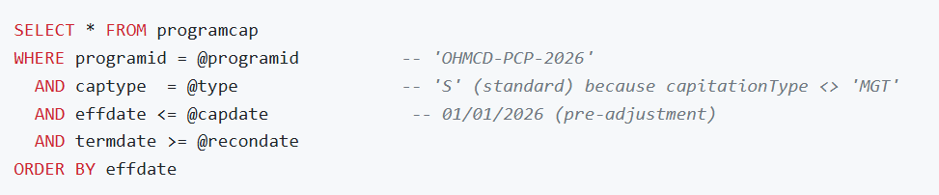

programcap tells the engine how to prorate a partial month. If a member enrolls or terminates mid-month, the program may pay a split percentage before/after splitmonthday (firsthalfpercent/sechalfpercent), or prorate by day based on ageday, or pay the full "true cap". These rules are loaded now and carried in the message so HOP 3 can apply them per member. For a standard PCP program (captype 'S') this governs new-born and mid-month-move proration.

- True-cap date adjustment
"True cap" means pay a full month's capitation to whoever is the member's PCP as of the end of the month, regardless of mid-month churn. To find everyone active at any point in the month, the engine moves capdate to the last day (01/31/2026).

- LoadOpenPayments() READ tables payment + capvoucher
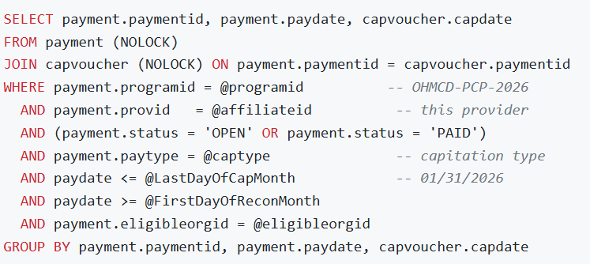
Before building a new payment, the engine must know what this provider was already paid for months inside the reconciliation window. These "open payments" are stashed in the message (Step 12 enrichment) so HOP 3 can net new-vs-already-paid and avoid double-paying the same member-month. This is the backbone of capitation reconciliation.

- Branch to the PCP builder
PCP walks memberpcp -table(members assigned to a doctor)

- ValidateCapFactorProgramFundsForAffiliations() READ warning-only
For the provider's affiliation list + program + capdate, it looks for capfactors whose configured fundid is invalid / not defined for the program. For each hit with a non-blank fundid it writes a WARNING naming the affiliationid, factorvalueid, and capdate.
Capitation that uses "capfactors" draws from program funds. A misconfigured fund would silently mis-post money in HOP 3. This pre-flight check surfaces the misconfiguration as an actionable warning before payments are built, without stopping the run. Pure diagnostics — no business-table writes.

- Inside Build_PCP_Enrollments()
- CheckPayHolds() READ warning-only · runs only if loginfo on
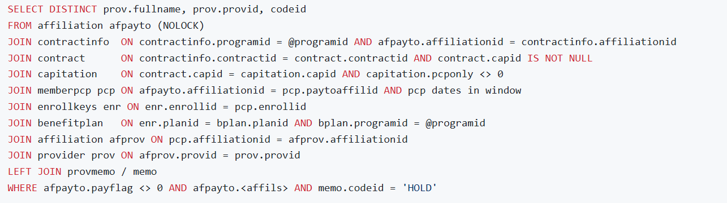

A provider can be flagged HOLD (e.g. credentialing lapse, investigation). Such providers must not be paid cap. This step's only job is to warn ("...is on payhold and will not be paid cap!") so operators see why a provider was skipped. The actual exclusion happens in Step 10's retrieval SP, whose WHERE clause carries memo.codeid <> 'HOLD' OR memo.codeid IS NULL. Running only when loginfo is on avoids the cost when nobody will read the log.

- Allocate the first queue id WRITE (id sequence)
The capmessagequeueid is the batch key that links staged enrollments → payment → HOP 3 processing.

- Execute spQ_BuildPCPCapMessage WRITE table capmessagequeue
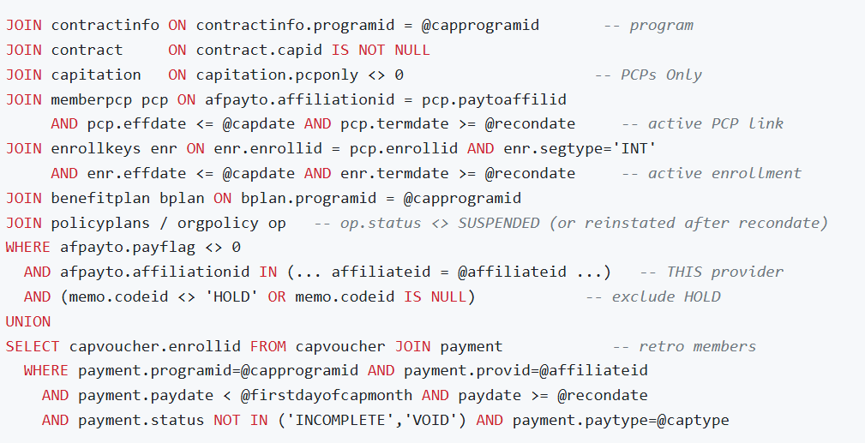

Bussiness logic:
- memberpcp — the whole point: pay the PCP for members assigned to them.
- capitation.pcponly <> 0 — only PCP-style caps; global caps are a different run.
- enrollkeys.segtype='INT' — only internal (real) enrollment segments, not audit/history rows.
- orgpolicy.status <> SUSPENDED — don't pay cap for members whose policy premium lapsed (unless reinstated within the window).
- benefitplan.programid — the member's plan must belong to the program being capped.
- memo.codeid <> 'HOLD' — enforce the pay-hold exclusion warned about in 8a.
- UNION retro block — pull members paid in a prior month inside the recon window so terminations/retro changes reconcile even if they're no longer in current contracts.
@PreRank <> @Rank guard? RANK() over(order by memid) gives every row of the same member the same rank. The new-batch cut only fires when the count is exceeded and the member changes — guaranteeing all of a member's enrollment segments stay in one batch.
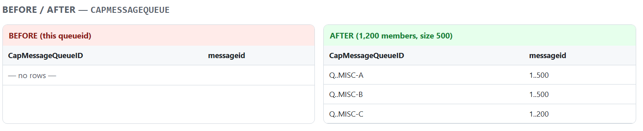
- Summarize batches & log the split READ WRITE (process log)

- Enrich XML & CreatePayment()

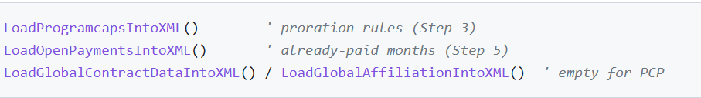
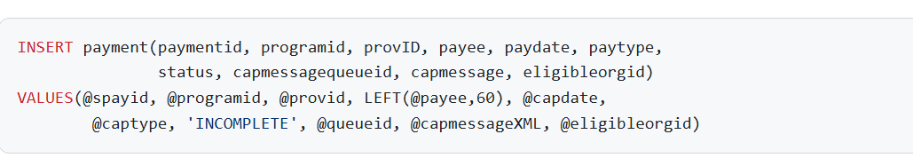
One payment header is created per batch so each batch is independently payable and restartable.
- CalcCapAdjustments() capadjustment → WRITE capvoucher + capadjustment
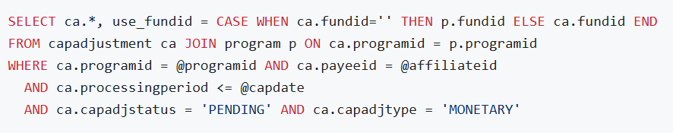
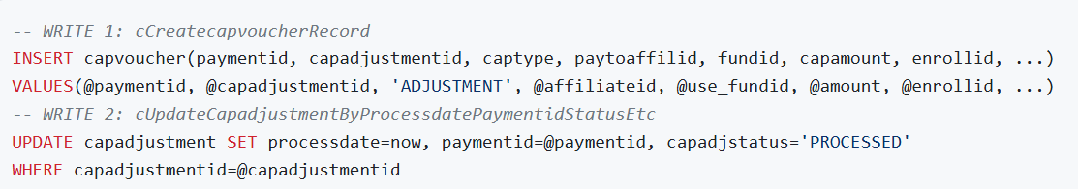

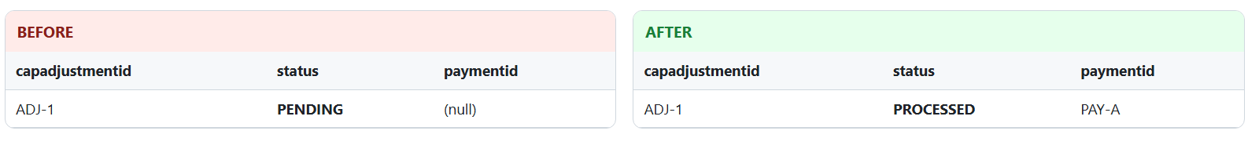
- Dispatch the batch
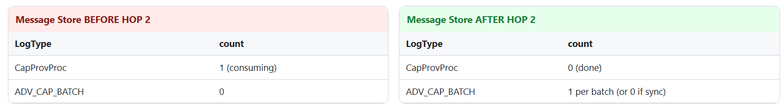

HOP 3

- LoadProgramcaps() + true-cap date re-align
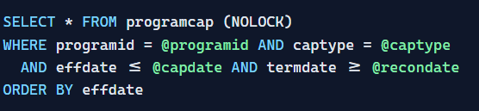

As the usetruecap='Y', capdate becomes 2026-01-31

- Read this batch's member rows READ capmessagequeue
loads every capmessagequeue row for this queue between firstmessageid and lastmessageid. Each row holds one enrollee's XML.

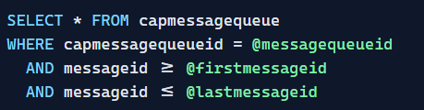

- LoadCapAdjustments() — RECON adjustments READ capadjustment
read pending recon adjustments
Loads any PENDING RECON cap adjustments for this provider/program/members, so retro reconciliation can be applied to the cap calc.
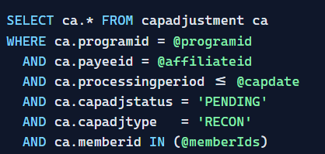

- CalculateCapitation() — the 5-stage money pipeline

- cBuildCapAffils:
cBuildCapAffils is a 100% read-only stage. It performs no INSERT / UPDATE / DELETE to any business table. Its entire job is to query eligibility, PCP, contract and copay data and assemble a "pay this affiliation, under this cap contract, for these day-counts, at this rate" context into the in-memory message XML for the next pipeline stages.

- LoadRateCodes() enrollcoverages (Eligibility)
A member's enrollment can carry several rate codes and coverage codes over time (e.g. a rate change mid-year). Loading them all now lets each month being processed pick exactly the codes effective that month .Rate code + coverage code are inputs to which cap rate applies.
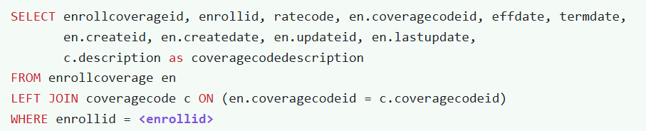

- LoadMemTier() READ member tier / cost-share (Eligibility)
Loads the member's tier / cost-share bands. Cap rates can vary by tier; the per-month tier id is attached for rate selection.
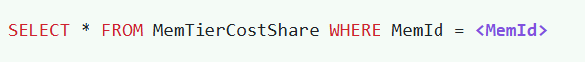

- LoadPolicycopays()
gathers the copay list and attaches it to the message — it doesn't do any math. Later stages (the amount/fund calculation) look at the cap contract: if it's a copay-net or premium-based arrangement, they take the member's copays from this list and subtract them from the cap amount before paying the provider. If the contract is a plain flat cap, the copays are simply ignored.
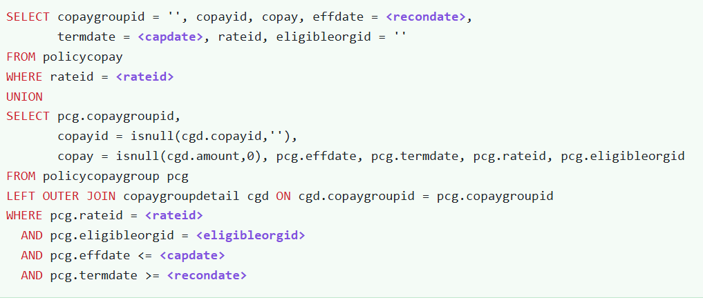

- BuildPCP() — PCP affiliations (WHO is paid)

m_affils — "Who do we pay?"
In this system the money doesn't go to the doctor personally — it goes to a pay-to affiliation, which is the billing/payment entity the doctor is attached to (a clinic, a group, a contracted entity). One doctor can bill under different pay-to entities.
This read finds the pay-to affiliation(s) that will actually receive the cap check for this member's PCP, under this specific program (OHMCD-PCP-2026), and only ones that are active and set up to be paid (payflag <> 0) during the period.

m_pcp — "Which PCP, and for which days?"
a member can have more than one PCP segment in a single month. Example — a member is with Dr. A from Jan 1–15, then switches to Dr. B from Jan 16–31. That's two segments in January.

Why we need all of them: capitation is often day-prorated. To pay correctly we must know exactly how many days the member was attached to which pay-to, so later logic can split the month (15 days to one, 16 to the other, or whatever the rules say). m_affils tells us who can be paid; m_pcp tells us for how long each was actually the PCP.

m_restrictions — "Any days we must NOT pay?"
Even when there's a valid payee and a PCP assignment, there can be periods where cap should not be paid — for example the member had other primary coverage, was in a carve-out arrangement, incarcerated, etc. These are stored as date ranges on the enrollment, and only the ones flagged as applying to capitation and not overridden are loaded.

Once these three are loaded and there is a valid pay-to affiliation, the code takes each qualifying affiliation and walks it month-by-month (BuildPCPMonths), using m_pcp for the day-counts and m_restrictions to trim ineligible days — building the month-by-month picture that the dollar-amount stage will price.

- BuildPCP() — enrollment restrictions The actual subtraction happens in RemoveRestrictions, and it works day-by-day:
- The month starts with a full billable day-count from the PCP assignment (e.g., 31 days).
- RemoveRestrictions lays out each day of the month and marks every day that falls inside a restriction period as "restricted."
- It counts those restricted days and subtracts them from the billable days.
- If restrictions somehow exceed the month, it floors the result at 0 (never negative).
Example:
- Member assigned to PCP all of January → starts at 31 days
- Restriction: Jan 1–10 (10 days) → marked restricted
- RemoveRestrictions: 31 − 10 = 21 billable days
- The cap amount is then prorated to 21 days instead of a full month.

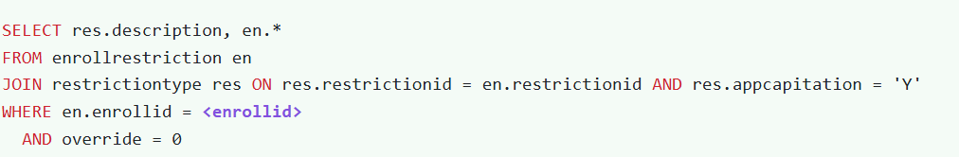
- BuildPCP() — all PCP assignment segments
Why "every segment" instead of just one
A member is not always with the same doctor for a whole month or the whole window. People switch PCPs. So one member can have multiple segments inside a single month.
Examples:
- Mid-month switch: Dr. A Jan 1–15, then Dr. B Jan 16–31 → two segments in January.
- Gap then re-assign: Dr. A Jan 1–10, unassigned Jan 11–20, Dr. A again Jan 21–31 → two segments to the same doctor.
- Reconciliation: because the window reaches back over prior recon months, you also get segments from those earlier months

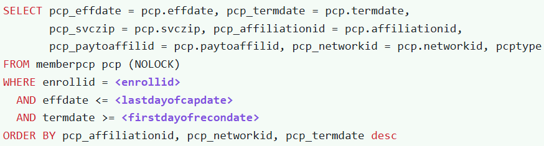

- GetCapData() — cap contract / terms (WHAT rate)
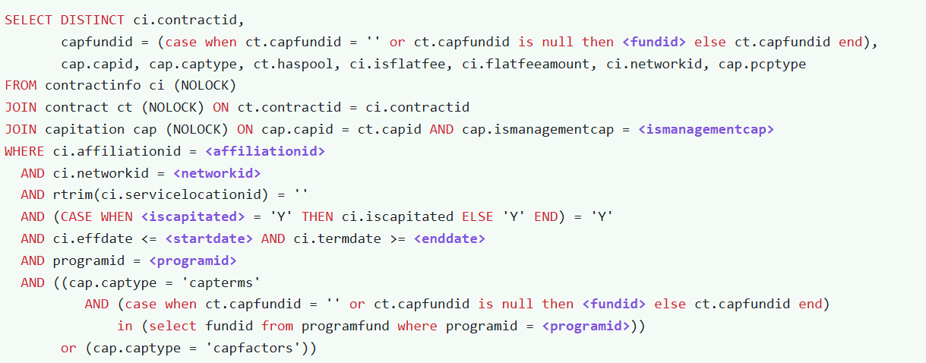

The chain it walks (three tables)
It joins three tables to go from "a provider affiliation" to "the actual cap rate definition":
- contractinfo (ci) — the provider's enrollment in a contract under a specific program/network. This is the "this affiliation is contracted under program OHMCD-PCP-2026" link.
- contract (ct) — the contract itself, which points to a cap (capid) and may name a fund (capfundid) and whether it has a pool (haspool).
- capitation (cap) — the actual cap definition: the rate schedule (capid), the pricing style (captype), the PCP type it applies to (pcptype), and whether it's a management cap.
Think of it as: provider → their contract → the cap rulebook that contract uses.
What each returned field means (the business payload)
- capid — the rate schedule key. This is the "price list" the next stage uses to look up the actual dollar amount. It's the single most important output.
- captype — how the cap is priced:
  - capterms = a fixed, flat per-member-per-month amount defined on a rate table (e.g., "$25 PMPM").
  - capfactors = a premium-based / factor-driven amount (e.g., "X% of the member's premium," possibly adjusted by age/gender/plan factors). This is why a later stage sometimes fetches the member's premium.
- capfundid — the fund the money is drawn from. Notice the CASE logic: if the contract doesn't name its own fund, it falls back to the program's default fund (<fundid>). Capitation dollars are accounted against funds, so this must be resolved.
- haspool — whether this cap feeds a risk pool (money withheld/pooled rather than paid straight out). Affects how the payment/withhold is handled downstream.
- isflatfee + flatfeeamount — whether this is a flat fee arrangement and the amount. (GetCapData even validates: if it's a capfactors flat-fee with amount ≤ $0, it flags the month as an error.)
- pcptype — the PCP type this cap applies to. This flows back into the PCP-segment filtering so only matching PCP segments are counted (ties together with the m_pcp logic you asked about earlier).
Where the output goes next
is consumed by the next pipeline stages:
- cBuildCapAmount uses capid/captype to fetch the base dollar amount (and premium if capfactors).
- cCapFundAllocation uses capfundid/haspool to split the money into funds/pools.
- The pcptype loops back to confirm which PCP segments count.
- CheckCapServiceZips()
Some capitation rates are geographically limited — the provider is only paid cap for members who live (or are served) in specific ZIP codes.
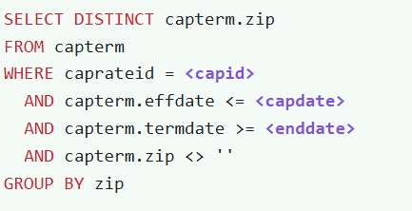

- LoadCarveOuts() : Runs only on the Global path (isGlobal=True)

A carve-out is a service that is pulled out of that global deal and handled separately. Even though the global group is capitated for "everything," the contract may say "...except these specific service categories, which are paid differently (or paid to someone else)
